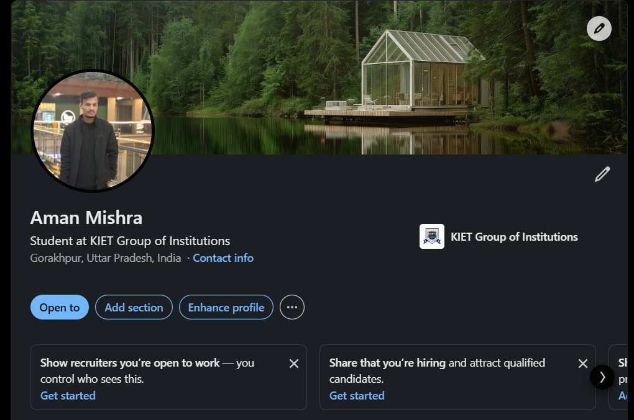
Link = www.linkedin.com/in/aman-mishra-5a9472381

